Dates to Remember  1st Utility Bills are mailed  15th Payment is due  16th 10% Penalty is assessed and final notices are mailed. 7 days after penalty is assessed bills remaining unpaid will be disconnected.  Note: Bills run a month behind therefore new customers may not receive their 1st bill for a month after service is established.  Payments  Payments can be made at City Hall during regular business hours. Payments made after hours can be placed in the drop box located by the office door or next to the city parking lot. Auto Bank Draft is available upon request, per account (nontransferable)  **Pay online at www.marionks.net**  City Dog Tags  Dog Tags are renewed yearly.  January 1st - March 1st the fee is $10.  After March 1st the fee is $15.  There is a $2.50 fee to reissue a lost tag.  Must show proof of current rabies vaccination when purchasing your dog tag. |  |  | City Events  Council Meetings  First and third Monday of the month at 5:00 pm  Municipal Court  Last Wednesday of the Month at 3:00 pm  Chingawassa Days  First Weekend of June  Art In the Park  Third Saturday in September  Old Settlers’ Day  Last Saturday in September  Contact Us  Phone: 620-382-3703  Office Hours: 8:30 am-5pm  Monday thru Friday  Web: www.marionks.net  City of Marion  208 East Sante Fe  Marion, KS 66861 |  |  | City of Marion  - The Town Between Two Lakes

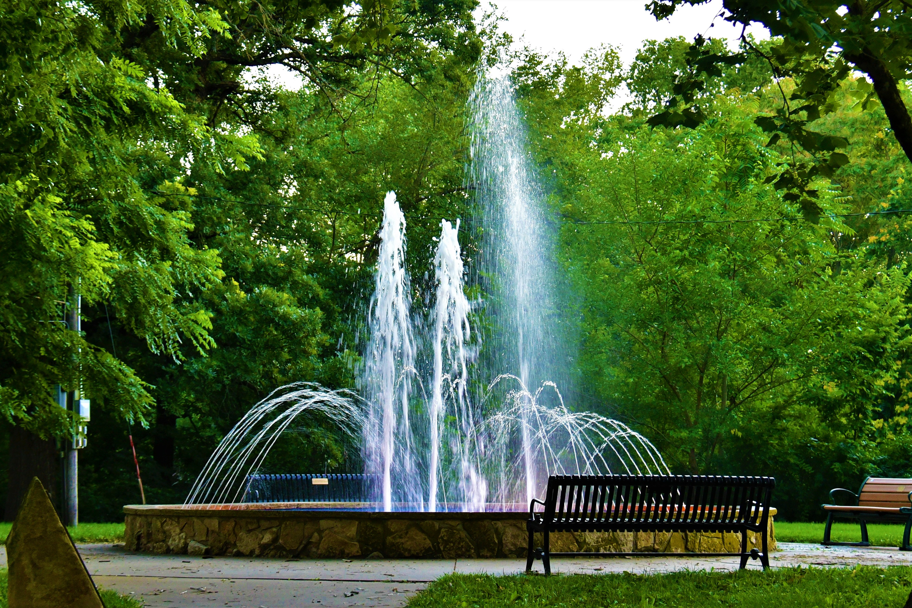  Building Permits General Information  A BUILDING PERMIT is required for structural changes affecting setbacks or roof lines and any electrical or plumbing. Contact the Building Inspector at City Hall.  Marion City Library  Hours: Mon-Thurs 10am-8pm  Hours: Tues, Wed-Fri 10am-5pm  Hours: Sat 9am-1pm  Phone Number 620-382-2442  Marion City Tree Dump  Yard debris, leaves and grass accepted.  Open Year around.  Marion Historic Museum  Hours: Monday, Wednesday Friday 12 pm-4pm  Hours: Saturday 10am -4pm  Closed during the winter months  Phone Number 620-382-9134 |  |  | Residential Utility Rates  Water Minimum $39.63, $6.80 per 1000 gallons  Electric Minimum $12.00, $0.1298/KWH  Sewer Minimum $20.00  Trash Minimum $10.50  Commercial Utility Rates  Water Minimum $39.63, $6.80 per 1000 gallons  Electric Minimum $14.00, $0.1298/KWH  Sewer Minimum $20.00  Trash Minimum $20.50  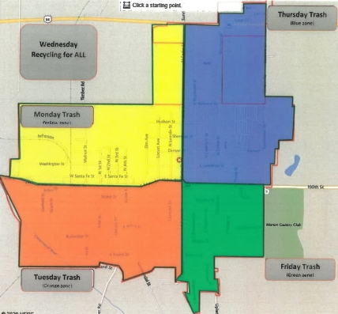  Trash days are determined on the map above. Trash is picked up on Monday, Tuesday, Thursday and Friday and MUST be bagged. Recycling is picked up on Wednesday only and MUST be loose in a container. Trash and recycling MUST be out by 8am.  Utility Connect Fee  Utility Connect Fee is $125. This fee is non-refundable. The fee can be waived with a letter of credit from a current utility provider.  Reconnects  To reconnect services that have been disconnected for non-payment a $50 fee is assessed. |  |  | 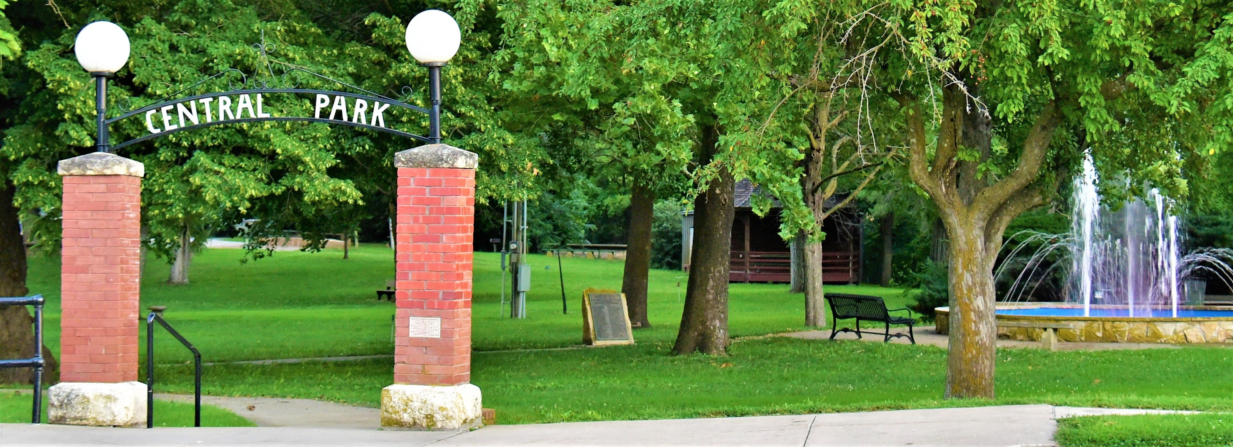  Phone Numbers to Keep Handy  Marion Police Dept 620-382-2651  Marion Co. Sheriff’s Office 620-382-2144  Marion City Hall 620-382-3703  Marion Electric Outage 620-382-6670  Marion Water Leak 620-382-6671  Marion Post Office 620-382-2363  Vyve Broadband (Eagle) 1-877-613-2453  Atmos Energy 1-888-442-1313  AT&T 1-800-231-1997  Marion Co. Clerk’s Office 620-382-2185  USD 408 District Office 620-382-2117  Marion Elementary 620-382-3771  Marion Middle School 620-382-6070  Marion High School 620-382-2168  Sports & Aquatic Center 620-382-2384  St. Luke Clinic 620-382-2033  St. Luke Hospital 620-382-2177

